**Use Case for Listing Removal**

**Title:** School Removal

**Description:** How schools are removed from the site

**Actors:** School, staff, the site

**Triggers**: school navigates to school removal tab

**Main Course:**

1. School logs in to existing account
2. School clicks on listing
3. School clicks on remove listing
4. Website checks for authentication
   * 2nd step password
   * Confirm decision to remove
5. Database gets updated with listing removal
6. School is informed about listing removal

**Alternative Course:**

1. Schools want staff to update the information on unused facilities, return to Main Course

**Exception(s):**

1. School is not listed
2. School has no registered login

**Pre-condition(s):** School must be registered and have at least 1 listing

**Post condition(s):** School listing is removed

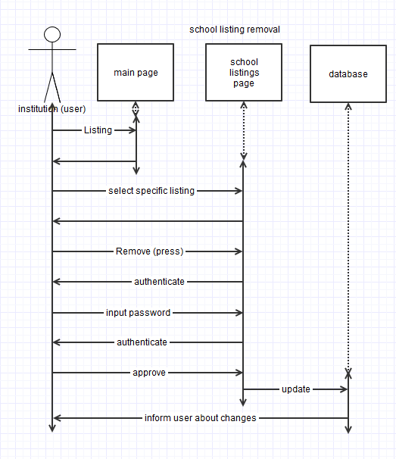

**Use Case for School Registration**

**Title:** School Registration

**Description:** Describe how schools are added to the site

**Actors:** School, staff, the site

**Triggers**: Staff needs to add qualified schools for promoting usage of unused facilities

**Main Course:**

1. Schools send in request to add their schools. Include a list of their unused facilities as well as the date/time the facilities are not in use.
2. If schools are approved, save/update information about the schools/unused facilities:

* School address
* School hours
* Name of unused facilities
* Date/Time
* Area in square meters
* Capacity
* Purposes/what they are used for
* POC information when problems arise concerning about the facilities

   4. Informs the schools about the approval

**Alternative Course:**

1. Schools want staff to update the information on unused facilities, return to Main Course step 2

**Exception(s):** Unqualified facilities, data entered is not saved

**Pre-condition(s):** Qualified schools with unused facilities the majority of the time outside of standard school hours

**Post condition(s):** Information entered are saved into the system

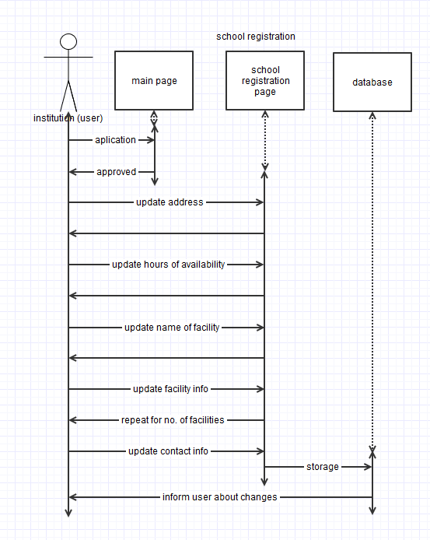

**Use Case for Renting Entire Venue**

**Name**: Renting unused facilities for private events.

**Description**: How to rent the space for private events and cancel the purchase?

**Actors**: Customer and Website

**Trigger**: Customer renting space and canceling the rented space.

**Main Course**:

**Step1**: Search space by zip code and city name.

Result: Lists of available space appears.

**Step2**: Click on the Rent button

**Step3**: Sign in or create new account

Result: Payment option will appear.

**Step3**: Enter name, billing address, and credit card number with expire date and CVS number.

**Step4**: click on proceed payment.

**Step5**: click on either print or email the confirmation page.

**Alternate Course**:

For canceling purchase:

Step1: Login to account

Step2: click on recent purchase

Step3: click on cancel purchase

Step4: click on either print or email the cancelled confirmation.

**Exception**:

1. Invalid credit card
2. space not Available

**Precondition**: Customer looking for desired space for private event.

**Post** **Condition**: Rented the facilities for private event.

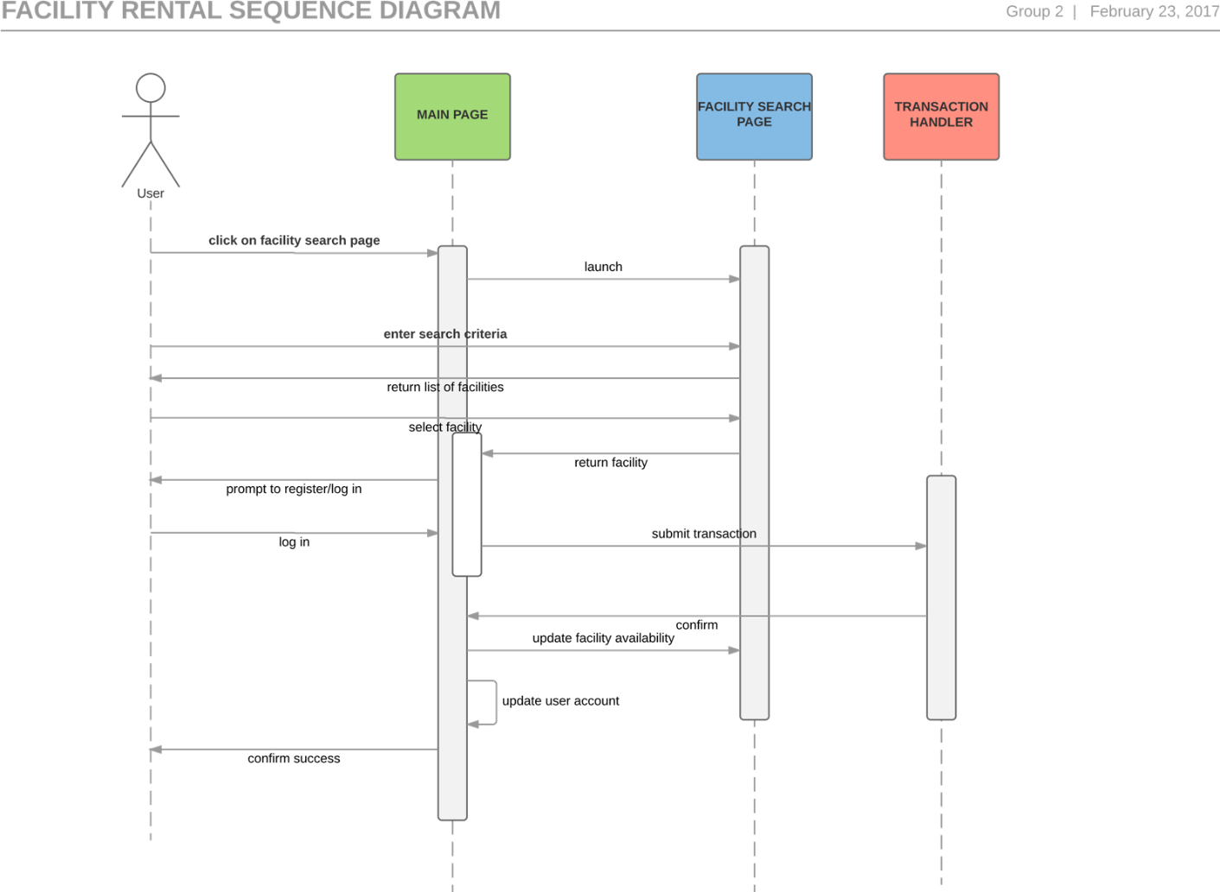

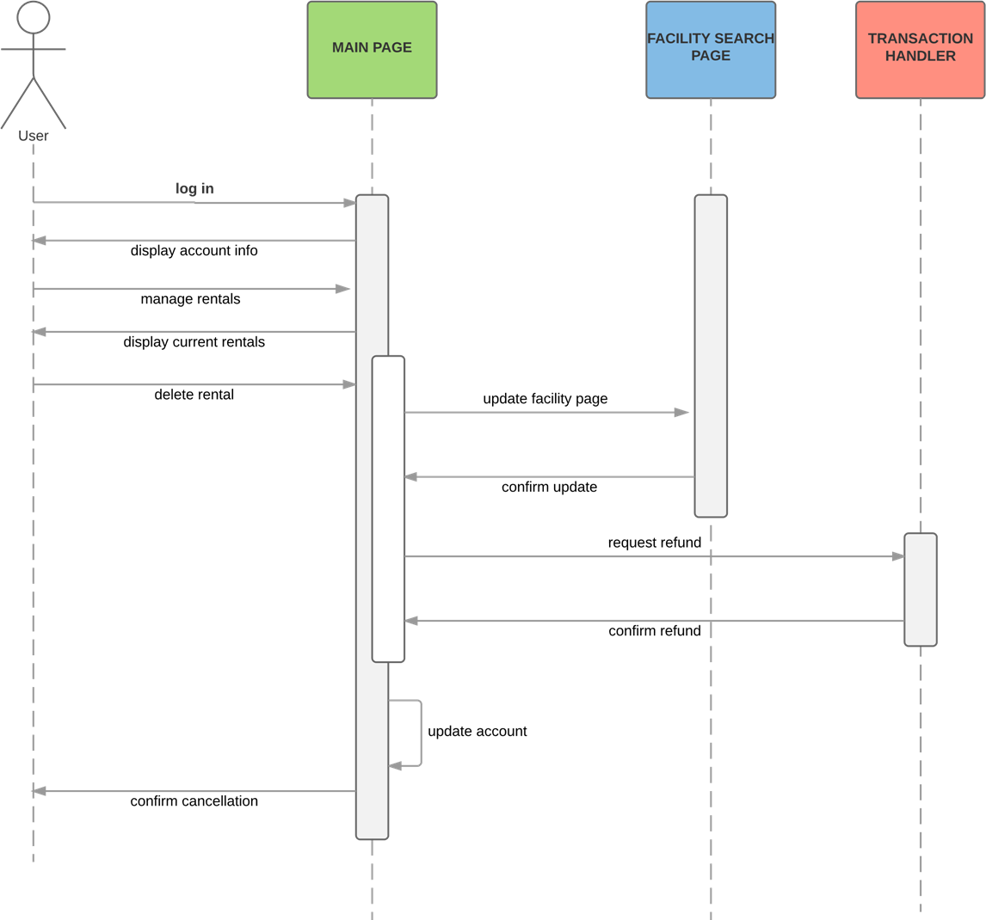

Use Case: Buy Tickets

Primary Actor: Ticket Buyer

Scope: Ticket Sales

Level: Summary

Stakeholders and interests:

Ticket buyer – gets the tickets sent to him or her

School - gets some money for the ticket.

Precondition: None

Minimal Guarantees: None

Success Guarantees: Buyer is sent tickets, payment is collected, attendance for event is increased.

Trigger: Buyer selects an event.

Main Success Scenario:

1. Buyer selects a school.
2. Buyer selects an event at that school.
3. Buyer confirms that they want to attend the event.
4. Buyer confirms the number of tickets they wish to purchase.
5. Buy sends payment info.
6. Payment is confirmed and tickets are emailed.

Extensions:

1a. Selected School is wrong.

1a1. Buyer reselects correct school.

2a. Buyer selects the wrong event.

2a1. Buyer reselects the correct event.

3a. Buyer changes their mind about attending event.

3a1. Start the process over and end it.

4a. Number of tickets they which to purchase is incorrect.

4a1. Ask for the correct number of tickets for purchase.

4a2. Buy provides correct number of tickets

4a3. Price is adjusted.

5a. Payment info is not correct.

5a1. Ask for correct payment info

5a2. Buyer supplies correct payment info

